AIM WITH THE EXERCISE:
YOUR CAREER PROFILE

To summarize your career profile in a template, that can be easily transformed and used in connection to composing a CV, job application, LinkedIn profile, Job bank profile etc.

HOW YOU DO IT:
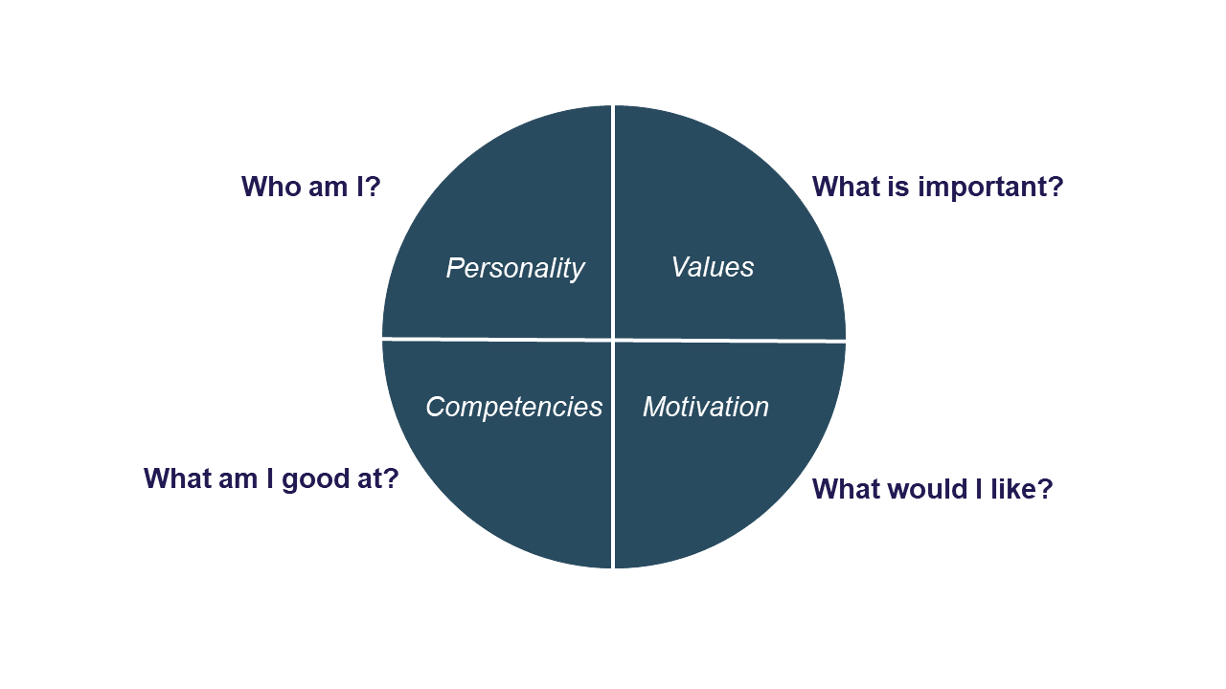
Use your knowledge from the other exercises in the module to fill out the sections. It does not have to be more than 1-2 sentences per section, but of course, you can write more. Only try to keep it simple and to the point. You might feel like rewriting some of your text from earlier, which of course is fine.

EXAMPLES:
Doing project work, I am the type, which look for new knowledge and come with new ideas, as well as I analyse and question the problem. I have focus on the task and I am determined in my work to get a good result.

It is important to me that we work with the task in a serious way. I can get impatient if too much time is spend on non-constructive discussions. I make high demands on others and myself.

I am motivated by professionalism and flexibility in the performance of the task. I work well with others, but I also believe that collaboration is not always the best solution. It can be beneficial to delegate parts of the task in a project (collaborating or individually).

I am good at thinking analytically, working with IT, bringing new ideas to the table and function as initiator. I meet the world with a wondering mind, and I often question the immediate.

I dream about working with organisational change processes. I can be in both a bigger as well as a smaller company. A good workplace for me is a place with room for differences of opinion, flexibility and the opportunity to develop. The worst thing one can do is to give me a closely defined task and tell me how to solve it.

A good first job for me would be as a kind of in-house development consultant, e.g. in a Human Resource department, Project Management Office, department of communication or the like.

My competencies: Experience with facilitation, strategy analysis, business understanding, communication strategies, management experience, coaching, creative processes and developing ideas, innovation, implementing strategies, evaluation, interview, participatory observation

My summary:
During project work, I am the type that…

It is important for me to…

I am motivated by…

I am good at…

I dream about working with…

A good first job for me would be…

My competencies:
Make a list with your 10 most important competencies as we speak

1.

2.

3.

4.

5.

6.

7.

8.

9.

10.

