COMPETENCIES
MIND MAP

PURPOSE WITH THE EXERCISE:
To create a mind map of your competencies.

HOW TO DO IT:
- Empty your head on paper, at the computer or at post-its. Do not be to self-critical.

When using the mind map method, you will be able to put your competencies into system. Where did you learn what? And how are the different competencies linked together?

Remember, it is fine to write the same competence several places. It is fine to be nerdy concerning your concepts. The most important is that you know yourself what the things mean and can.

Do yourself the favour of writing even the most `common´ things down – because things you believe you will always remember, can easily be forgotten.

It is a good idea to take specific correlations as a starting point, e.g. a specific project, and display your mind map from there. If you use this procedure for several projects, your mind maps will quickly overlap and create a total overview.

If you would like to use the computer for the mind map exercise, you can use online mind map tools such as for example www.bubble.us

EXAMPLE:

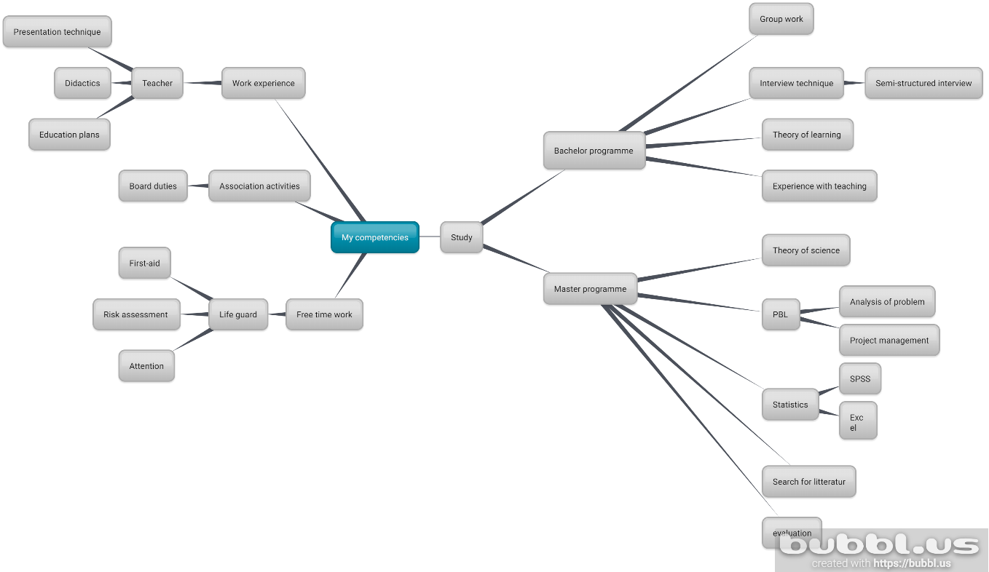

MY COMPETENCIES:

MY COMPETENCIES

