PURPOSE WITH THE EXERCISE:
COMPETENCIES
THE MODEL OF COMPETENCE

The purpose with this exercise is to vary and understand your competencies better through categorising your competencies.

HOW TO DO IT:
Use the competence model and the below mentioned 3 perspectives on competencies, for categorising your competencies from you gross list or mind map. Also, consider adding more competencies if you spot a category that you have not had on your list so far.
The 3 perspectives are:
- Personal competencies and professional competencies
- Hard competencies and soft competencies
- Context-dependent competencies as well as competencies not dependent on context

EXAMPLE:
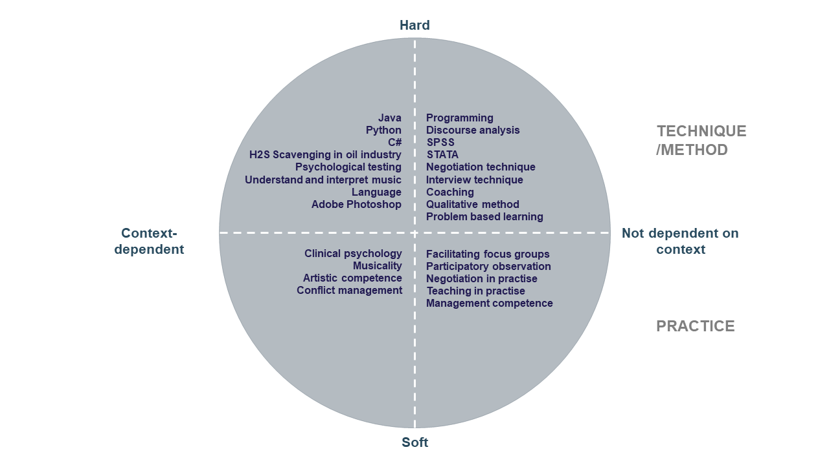

MY COMPETENCIES:

 | CONTEXT-DEPENDENT | NOT DEPENDENT ON CONTEXT
HARD
SOFT

